Annual Report of the NAEYC Affiliate Advisory Council
January 2020 – December 2020
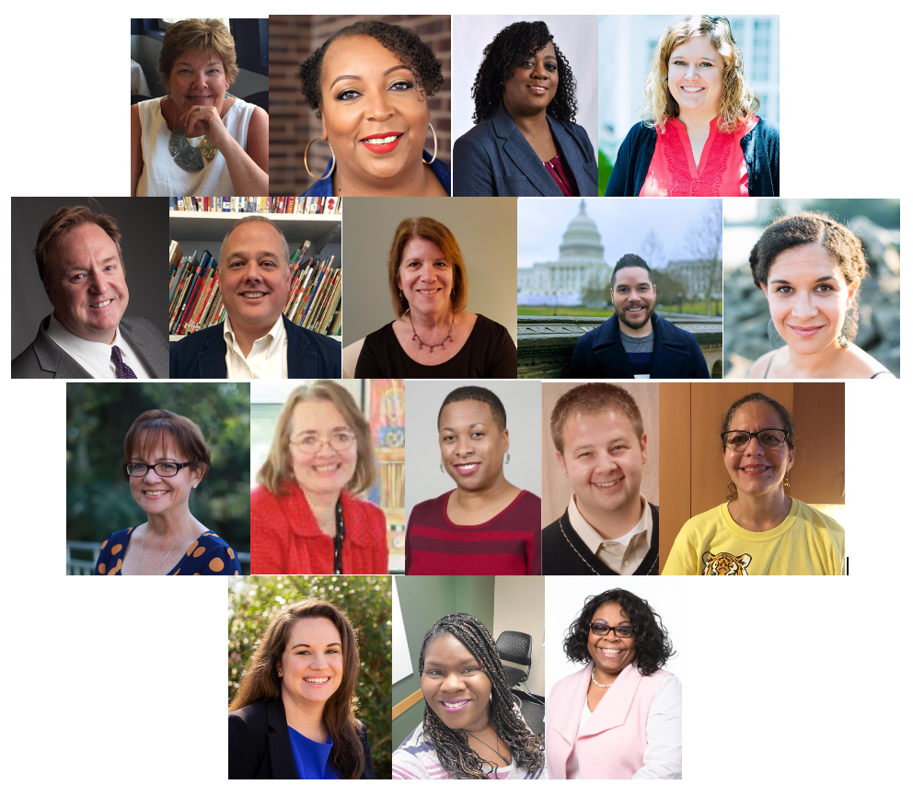

Mission: The NAEYC Affiliate Advisory Council acts as an advisory body to support the continuing transformation of the NAEYC Affiliate structure into a high-performing, inclusive organization.

Purpose: To advise the NAEYC Governing Board and national staff about all issues related to Affiliates and members, and to identify and develop strong, inclusive leadership.

See the 2019 Report

Current Affiliate Advisory Council Members
Kelly Ramsey, Continuing Chair, (OK), Robyn Lopez Melton, Continuing Past Chair, (OR), Tara Hurdle Chair Elect, (TN), Dr. Mike Abel (MO), Dr. Chris Amirault (OK), Michelle Barnea (NJ), Dr. Eric Bucher (AZ), Zaina Cahill (PA), Dr. Raquel Munarriz Diaz (FL), Dr. Melanie Felton (IA), Dr. Helene Harte (OH), Dr. Brian Kingrey (IA), Dr. Margarita Marichal (PR), Dr. Jodi Nerren (TX), Dr. Ashley Simpson (CO), Crystal Sanford-Brown, NAEYC Governing Board Vice President and Liaison to the Council. NAEYC Staff: Gwen Simmons and Sandra Del Rio (through July 2020)

Affiliate Advisory Council Member Terms Ending June 2020
Shanna Kukla, Cary Larson-McKay, Mandisa Routheni, and Lydia Bowers

NAEYC Governing Board Committee Work: Members of the Affiliate Advisory Council were honored to serve on several committees. Affiliate Relations: Robyn Lopez Melton, Early Learning Systems: Chris Amirault (January- April), Michelle Barnea (May- December), Member Engagement: Tara Hurdle, and Nominations: Brian Kingrey.

Introduction
The Affiliate Advisory Council was created in 2015 as a nimble and efficient advisory body to replace the former Affiliate Council at the time NAEYC adopted a new affiliate structure. The Council’s 16 person structure was designed to ensure that NAEYC Governing Board members and national staff have an advisory group they can access to better understand the needs, challenges and success stories of the Affiliate Network, and to learn from affiliate experience. The Affiliate Advisory Council is staffed by, and works very closely with the Affiliate Relations Department at NAEYC. Since its inception, the Affiliate Advisory Council has continued to focus on NAEYC’s strategic direction, and especially our commitment to HPIO, Equity, Diversity, and Inclusion.

2020: A Year to Remember
2020 strained the field, NAEYC, the Affiliates and the Council. In this year of unforeseen circumstances, the Affiliate Network and this Council responded quickly to address the impact of COVID-19 on the field, members, early educators, families, and the emerging needs of their communities as well as their own organizations. Many Affiliates discovered new ways to use technology in place of physical connection. Affiliates cancelled events and reorganized professional development opportunities, created virtual learning opportunities to support educators, and searched for new ways to connect with members and support early childhood professionals in their communities, all while keeping themselves, their families and staff safe from the pandemic by working remotely. Members and the field turned to our Affiliates as their main and trusted source for information and most importantly, as the interpreters of the ever changing rules, regulations, and program requirements. The Council recognizes and celebrates the tremendous efforts Affiliates put forth in support of our members and the field over the past ten months.

The Council was able to have only one in-person meeting before the pandemic restricted travel. The February meeting at the NAEYC headquarters included opportunities to meet with NAEYC senior staff- Gill Walker (Director of Marketing and Mentorship), Jill Harris (COO and CFO), Lauren Hogan (Managing Director of Policy and Professional Advancement), and Michelle Kang (Chief Strategy and Innovation Office). NAEYC President, Amy O’Leary, joined the Council in February to continue discussion of our 2019 recommendations to further promote the goals of access to the organization through the lens of diversity, equity, and inclusion.

The Council continued to meet virtually throughout the year, lamenting the missed opportunities to meet incoming council members in person, and to network with Affiliate leaders and each other face-to-face at NAEYC conferences and events. The Council found new ways to move forward with our work, including participating in dialogues with Affiliates and governing board committee work.

The Council would also like to acknowledge the work of Sandra Del Rio. Sandra was an asset to the Council, the Affiliates, and the Affiliate Relation Department. The loss of that position and her expertise is another difficult circumstance caused by the strain of the pandemic.

2020 Council Application Process
The Council appointed five outstanding, qualified individuals, and two alternates from a pool of over 29 applicants. The Nominations Committee consisting of a past NAEYC Governing Board member, three At-Large members, and chaired by Cary Larson-McKay, reviewed all eligible applications rating each candidate’s responses on a five point scale similar to the NAEYC Governing Board’s scale, taking into consideration age, gender, race, and ethnicity demographics along with geographic location. New Council members include; Dr. Eric Bucher, Dr. Jodi Nerren, Dr. Melanie Felton, and Dr. Ashley Simpson, and Lisa Roy and Rebecca Lamar as alternates.

In order to limit the annual turnover of council seats to three, the Council approved one year term extensions for Chris Amirault, Brian Kingrey, Margarita Marichal, Helene Harte, and Raquel Diaz. The Council recognized the service of Lydia Bowers and Mandisa Routheni who resigned for personal reasons, wishing them well in their future endeavors. Tara Hurdle was elected Chair-Elect, and the Council confirmed one year extensions for Kelly Ramsey, Chair and Robyn Lopez-Melton, Past Chair to round out the leadership team.

Affiliate Dialogue Pilot: An Opportunity to Deepen Maine AEYC’s Understanding of HPIO
A unique and timely opportunity was presented to the Council during the summer of 2020. Heather Marden, President of Maine AEYC, fueled by her participation in a Council session at the NAEYC Annual Conference in November 2019, “Living into Diversity, Equity and Inclusion: NAEYC’s Affiliate Advisory Council’s Journey”, invited Council members to participate in a collaborative effort to assist them in a series of crucial conversations on diversity, equity, and inclusion.
The story of the Council’s journey was powerful. It was not perfect. It was REAL. It was not always comfortable. It was HONEST. It was not a beginning or an end. It is UNFINISHED. This was a step in our Affiliate’s journey to broaden our perspectives, begin uncomfortable conversations, and learn from one another beyond our Maine borders. From this, we took away a commitment to changing our Board culture. A culture that was best described by a member as ‘sterile.’ [Heather Marden, MaineAEYC Board President]
The Council embraced the invitation from Maine AEYC, collaborating with leadership in planning critically important conversations on how to create a board culture of equity and inclusion, and on the importance of examining current board culture. Key questions included;
Who is at the table and who is missing? What is Maine AEYC’s message and vision and how does it guide the board nomination process and meetings? Why should someone join the Maine AEYC board? How will they have a voice? How will they fit in?
Maine AEYC conducted an election process that put equity and diversity at the forefront of vetting candidates. Every candidate was asked to describe their stance on diversity/equity and any background or experiences they had in incorporating these priorities into their work. It was important for our voting membership to read how candidates would help our Organization move forward to becoming more diverse and equitable. Elections Infographic
In November 2020 the Maine Board reached out for a second time - eager to continue the collaboration by partnering with the Council in creating a stronger connection with NAEYC, and to provide a meaningful opportunity to onboard their newest board members, who bring an expansion of diverse voices and experiences to their affiliate. We at Maine AEYC want to offer our deepest appreciation for your leadership, mentorship, and partnership. You are paving the way for our Affiliate and others with your meaningful, intentional work.
The Council discussed how this process could be a support for other affiliate boards and identified practical steps and guiding principles that can be implemented with other affiliates moving forward.
- Affiliate board members need to be willing participants. The invitation should come from the affiliate.
- This needs to be part of an experience that evokes the desire to change
- Recognize that this work is not a one-time experience, but an ongoing and intentional, internal process for affiliate boards.
- The affiliate board needs to grapple with their own culture and ask how it influences these conversations and impacts decision-making.
- It’s an iterative process in which the affiliate board has internal conversations, and includes available collaboration with the Council.
- Provide specific suggestions, tied to how the Council structures meetings such as starting each meeting with equity discussions rather than placing it at the end of the meeting.
- Provide specific guidance on leaning into and being okay with the uncomfortable - the discomfort.
- Suggest resources and equity tool-kits such as the Four Agreements from Courageous Conversations About Race by Glenn Singleton.
The Council remains committed to advancing equity throughout the Affiliate Network with Maine’s journey as a potential model for other affiliates. As Heather noted, Maine is the whitest state in America. It is a characterization that our Affiliate has had to analyze and refute. To accept this statement even in its simplest form of statistical data, would deny the deep-rooted history we have in cultural and racial diversity. Maine AEYC is committed to continuing this journey and not allowing a characterization to become an excuse.
See Appendix C for the MaineAEYC proposed timeline of the process.
Recommendations to Governing Board
The Council recommends the following:
- Increase focus on a leadership model for young professionals in the field, elevating students’ and new professional voices to promote engagement, membership, and progressive early childhood values and theories.
- From 2019: Continue to support Affiliates in their equity and diversity work. Invest in creating resources and materials to lead equity and diversity work in their communities. This should include a continued focus on access, including access to NAEYC resources for students, marginalized communities, individuals with disabilities, and in languages reflective of NAEYC membership, including Spanish and Mandarin.
- Consider innovative solutions to support Affiliates’ interests as they work to support and engage the field with limited financial resources due to the hardships of 2020 and the continued impact of COVID-19.

The Council also recommends that the Governing Board take further action to encourage and support young leaders in the field. In years past, NAEYC has engaged in this work through the Young Professionals Advisory Council, virtual spaces for this initiative, and membership outreach to this group. However, continued work in this area appears to be at a standstill. Affiliates have expressed an interest in supporting this same work at the local level; however, they are seeking models of this work to inform their practices with young professionals in their communities. If we are to stay relevant to the newer generations of the workforce, we must provide support to these professionals.

The Council acknowledges and appreciates the continued focus on diversity, equity, and inclusion that NAEYC has committed to, even in the midst of the pandemic. Prior to 2020, NAEYC was offering ongoing training and support available to Affiliate leaders. The Council recommends that some focus be turned again to creating and providing resources, such as tool- kits and train-the-trainers for Affiliate leaders to continue this work in their own communities. Funding from the Heising Simons grant has been a source of support to deepen this work at the affiliate level. The Council is prepared to provide guidance and suggestions at the national level. The investment in creating and sharing resources will provide an economy of scale in advancing this work at all levels, and promote collaborative spaces where Affiliates are learning from one another. Instead of each individual Affiliate creating their own materials, shared resources will provide all Affiliate leaders the tools needed to make real impacts in their communities and further reflect NAEYC’s commitment to advancing equity. Shared resources will also make access to resources for students, marginalized communities, individuals with disabilities, and non-English speakers more attainable at a larger scale.

2020 brought unique and widespread challenges that have strained Affiliates. Affiliates are looking for new ways to connect with members and support early childhood professionals in their communities while also managing reduced budgets and revenue opportunities. They are implementing new technologies and encountering new barriers. NAEYC has the advantage of economy of scale. Providing innovations, support and resources on a national level means reducing duplicated efforts for Affiliates and allows them to be more responsive to their communities.

We look forward to continuing our work in support of members, affiliates and NAEYC in 2021.

Respectfully,
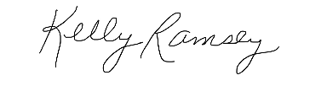
Kelly Ramsey, NAEYC Affiliate Advisory Council Chair
NAEYC Affiliate Advisory Council Members

Appendix A - 2020 - Year In Review
February--
- Met in person at NAEYC headquarters
- Discussed NAEYC’s Reorganizational Plan with Jill Harris, COO and CFO
- Met Michelle Kang, Chief Strategy and Innovation Officer
- Advised on materials and strategies to engage a diverse membership with Gill Walker, Director of Marketing and Membership
- Advised on Heising-Simons seed grant with Lauren Hogan
- Met with President Amy O’Leary in response to the 2019 letter to the Governing Board
- Meet and Greet with NAEYC staff
- Reviewed Data (NAEYC listens Survey, 2019 Annual Reports, CY20 Technical Assistance Plan)
- Accepted Mandisa Routheni’s and Lydia Bowers’ resignation from the Council
- Discussed how to best engage the Affiliate Network in ongoing dialogue about DEI
March--
- Approved and confirmed Robyn’s extended term as Past Chair for an additional year
- Notified Affiliate Staff Community of Mandisa’s resignation, and encouraged staff community applications for this seat
April--
- Elected Tara as Chair-Elect
May--
- Approved slate as presented by the Nominations committee
- Conducted exit interviews for outgoing members- Cary and Shanna
June--
- Welcomed four new members
- Council mentors met with new members, conducted orientation
- Begun re-thinking of the Council’s work plan as a result of COVID-19
- Margarita, Helene, Kelly, Tara and Gwen attended the June board meeting for MaineAEYC.
October---
- Continued revising the Council’s work plan as a result of COVID-19
November--
- Planning for the Council’s dialogue with WashingtonAEYC regarding DEI
- Participated in NAEYC’s virtual Annual Conference and engaged in recruitment sessions
- Planning session with Maine AEYC Board, attended Kelly, Tara, Helene, and Gwen
December--
- Prepared and summarized council survey data on supporting NAEYC’s work with affiliates during the pandemic
- Continued planning for the Council’s dialogue with Washington AEYC
- Kelly, Tara and Gwen attended the full board meeting with Maine AEYC
Ongoing
- Co-facilitate monthly Leadership Webinars and author Affiliate Connections e-news articles (see attached samples on pages 8-10)

Appendix B - Affiliate Connections articles authored by Council members

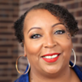It’s No Longer Business as Usual, Kelly Ramsey (OK)
Over the past months, we have experienced an upheaval of systems that previously provided us with a sense of security and comfort. As we have been required to draw in and practice physical distancing during the COVID-19 pandemic, we are learning more about our need for connection personally, in our work, and profession. The current operating systems have exposed gaps in resources and accessibility when viewed through the lens of diversity, equity, and inclusion. We can no longer continue business as usual.

The challenge for the Affiliate Network and NAEYC is to look for innovative strategies to grow and retain members, to engage members in new ways, and to explore and implement virtual professional development opportunities where appropriate. Post COVID-19 provides a space to consider many aspects of our work. What are the resources Affiliates are able to provide to support the gaps in services experienced by members, families and providers? When the workforce reenters the doors of their family childcare home, center-based programs, faith-based programs what will teaching staff need to address daily program needs? Are there supports in place that address trauma-informed care? These questions provide a space for all of us to examine existing structures and identify tangible resources - not all of which can be virtual. Technology barriers are real and must be considered as we move forward.

Here are three things we can focus on: Re-engage membership to support the childcare profession as a whole;
- Join our OH, TX, ME, MD, PA, and FL in offering membership listening sessions to share concerns
- KSAEYC conducted “comfort calls” by board members - a personal touch for members to see how they are doing
- Organize local distributions of learning materials for parents
- Create a book reading challenge or bookclub to engage teachers virtually similar to MIAEYC and COAEYC
In the Hello community, conversations are raising important questions. Join these conversations to see what others are doing and to inform the dialogue. We need everyone working together to support the efforts to strengthen our work on the local and national levels. We are better together, and have what it takes to support our community. Let us join together.

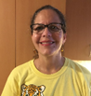Me siento representada, Margarita Marichal (PR)
¿Qué significa ser representado? El diccionario lo define como “la acción de hablar o de actuar a favor de otro o la condición de ser representado.” En los medios de comunicación, el término se utiliza para presentar a las personas según su edad, género, grupo étnico, identidad nacional o eventos a una audiencia muchas veces ignorante del significado de cada una de esas categorías. La manera en que los medios representan a ciertos grupos puede ser muy influyente y se presta para desarrollar actitudes, ideas, y prejuicios nocivos. Esos prejuicios se relacionan con la raza, género, clase social, cultura, lengua materna, orientación sexual, religión y muchos otros factores.

La Asociación Nacional de Educación para la Niñez Temprana (NAEYC) ha desarrollado un documento que presenta su posición sobre cómo adelantar los esfuerzos para lograr la equidad en la educación de la niñez temprana. En este documento se han reseñado las desigualdades en la distribución de poder y de privilegios que impactan directamente a los profesionales de niñez temprana y a los niños de la nación. La NAEYC enfatiza en la importancia de hacer introspección y de reconocer los prejuicios que hemos aprendido a través de las estructuras sociales y del sistema educativo. Este documento es producto de mucho trabajo y esfuerzo, y tiene como propósito minimizar la falta de oportunidades de los grupos sociales marginados que son víctima de prejuicios aprendidos. Me pregunto si este documento será suficiente para promover la equidad y erradicar prejuicios.

Soy una mujer Latina, trigueña, con barreras de lenguaje y ,a través de mi vida, me he sentido poco representada. Los prejuicios están integrados en nuestro inconsciente y muchos tenemos prejuicios contra nosotros mismos. Este auto-sabotaje puede manifestarse de diferentes maneras: cohibirnos de hablar y defender nuestros derechos, no adelantar nuestras metas por no atrevernos a arriesgarnos, no manifestar nuestra creatividad entre otros. Este auto-sabotaje o prejuicio contra nosotros mismos responde en gran medida al hecho de que no nos sentimos representados. Hay una gran diferencia entre ser representado y sentirse representado. Sentirse representado involucra que otros compartan nuestras creencias y valores, y que las hagan valer activamente.

En estos días me he empezado a sentir representada por una mujer trigueña, nacida de inmigrantes, y justiciera. Tengo muchas esperanzas de que todos los profesionales y niños que pertenecemos a los grupos no privilegiados tengamos una representación digna. Estamos en una nueva era por lo que invito a todos los miembros de NAEYC a reflexionar sobre sus prejuicios y a abrazar la idea de que sí podemos conseguir la equidad para todos los niños pero que tenemos que trabajar activamente para ello.

Feeling Represented – Margarita Marichal
What is representation? The dictionary defines it as “the action of speaking or acting on behalf of someone or the state of being so represented.” In the media, it is how gender, age, ethnicity, national identity and events are portrayed to an audience. These portrayals could be very powerful in the development of attitudes, ideas, and biases. Those biases are related to race, class, culture, language, gender, sexual orientation, religion, and many other factors.

The NAEYC Advancing Equity in Early Childhood Education Position Statement uncovered the uneven distribution of power and privileges impacting early childhood education professionals and the children in this nation. It emphasized the importance of conscious reflection as we all have biases that are rooted in the political, social, and educational systems. This position statement is a thoughtful work and effort to bridge the gap of opportunities that certain social groups have because of societal structures and biases. But, is that enough to promote equity and eradicate biases?

As a Latino woman of color, with language barriers, I typically found myself underrepresented. Biases are deeply rooted in our unconscious selves and some people are even biased against themselves. Bias against ourselves can take many forms: keeping us from speaking up, not taking opportunities, refraining from being creative. I believe that it has to do with the feeling that you are not represented and that your contributions might seem worthless. There is a huge distinction between being represented and feeling represented. Feeling represented as a woman of color is about sharing beliefs and turning words into action.

I am starting to feel represented by a woman of color, born to immigrants, a justice seeker, and my hopes are high for all the professionals and children of this nation that have been underrepresented for centuries. This is a new era and I invite all NAEYC members to reflect on your own biases and to welcome the thought that equality for all children is possible if we turn our words into actions.
Appendix C- Maine AEYC’s Timeline of Diversity and Equity Work 